Series: Christmas in Guangzhou (Winter 2019)/ Requalifying for Premier Silver on United

Red are flights/train rides/hotel stays that I will not report.   
**Bold** are completed reports. Should have a link to the Word document.   
*Italics* are confirmed plans… have PNR/Confirmation code.   
Highlighted are changes to the plan.

1. [**United Airlines Boeing 737-900ER Minneapolis to Denver in First Class**](1-%20UA1864%20MSP-DEN%20First%20Class%20B739ER.docx) **(CPU Confirmed)**
2. [**United Club Denver-West (near Gate B32) (no report… did not have time to enjoy lounge)**](2-%20United%20Club%20Denver%20B32.docx)
3. [**United Airlines Boeing 757-300 Denver to San Francisco in Economy Class (Economy Plus Exit Row)**](3-%20UA268%20DEN-SFO%20E+%20Exit%20Row%20B753.docx)
4. [**United Airlines Boeing 777-200ER San Francisco to Shanghai Pudong (Economy Plus Exit Row)**](4-%20UA891%20SFO-PVG%20E+%20Exit%20Row%20B772ER.docx)
5. [**JW Marriott Hotel Shanghai at Tomorrow Square**](5-%20JW%20Marriott%20Shanghai.docx)
6. [**China Eastern Airlines ~~Boeing 737~~(Cancelled) Airbus A330-300 Shanghai Hongqiao to Guangzhou**](6-%20MU5311%20SHA-CAN%20A333.docx)
7. [Hingyue Restaurant… near Xiaobei](7-%20Xingyue.docx)
8. [Redemption time: Easeland Hotel, Guangzhou](8-%20Easeland%202.0.docx)
9. [Winter… Lights of Guangzhou, Baiyun Hill, and Yuexiu Park.](9-%20guangzhou%20NF.docx)
10. [China Eastern Airbus A330-300 Guangzhou to Shanghai Hongqiao](10-%20MU5312.docx)
11. China Railways High-Speed Shanghai Hongqiao to Suzhou CRH380BL First Class
12. Courtyard Marriott Suzhou Mudu, Suzhou
13. China Railways High-Speed Suzhou-Nanjing CRH380D First Class
14. Winter… Nanjing City Wall, Xuanwumen, Confucius Temple
15. China Railways High-Speed Nanjing-Suzhou CRH380D Second Class
16. China Railways High-Speed Suzhou-Shanghai Hongqiao CRH2C First Class
17. Shanghai Maglev Transit to Pudong Airport
18. Air China Business Class Lounge, Shanghai Pudong Airport (Star Alliance Gold lounge)
19. United Airlines Boeing 777-200ER Shanghai Pudong to Chicago (Premium Plus seat, Economy service)
20. United Airlines A320 Chicago to Minneapolis in First Class (CPU confirmed)

**Original:**

1. **United Airlines Boeing 737-900ER Minneapolis to Denver in First Class**
2. **United Club Denver-West (near Gate B32) (no report… did not have time to enjoy lounge)**
3. **United Airlines Boeing 787-8 Denver to Tokyo Narita**
4. **ANA Boeing 767-300ER Tokyo Narita to Guangzhou**
5. **The Westin, Guangzhou (Tianhe location)**

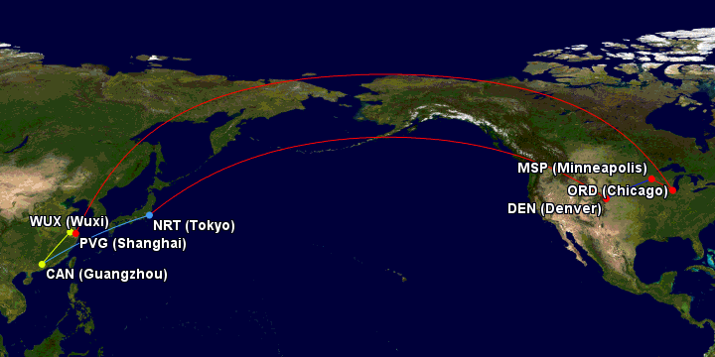

Turned into…

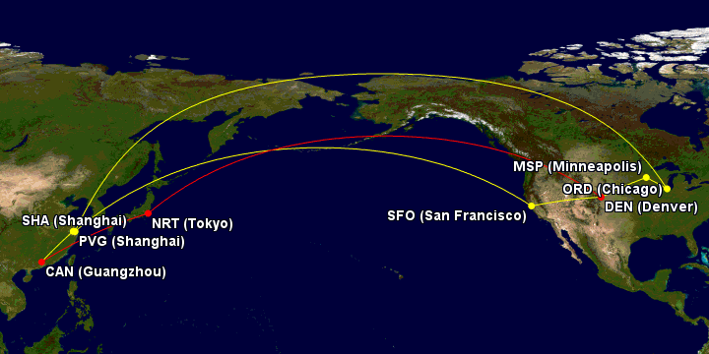

Gcmap.com

Not vlogging. Too much hassle to vlog… but maybe videos?